Faculty

Yung sa faculty, dapat merong time limit per question sa assessment builder kapag hindi 'Show all questions at once' yung picked option.

Dapat pwede mag reset ng password ng account yung admin in case makalimutan nila.
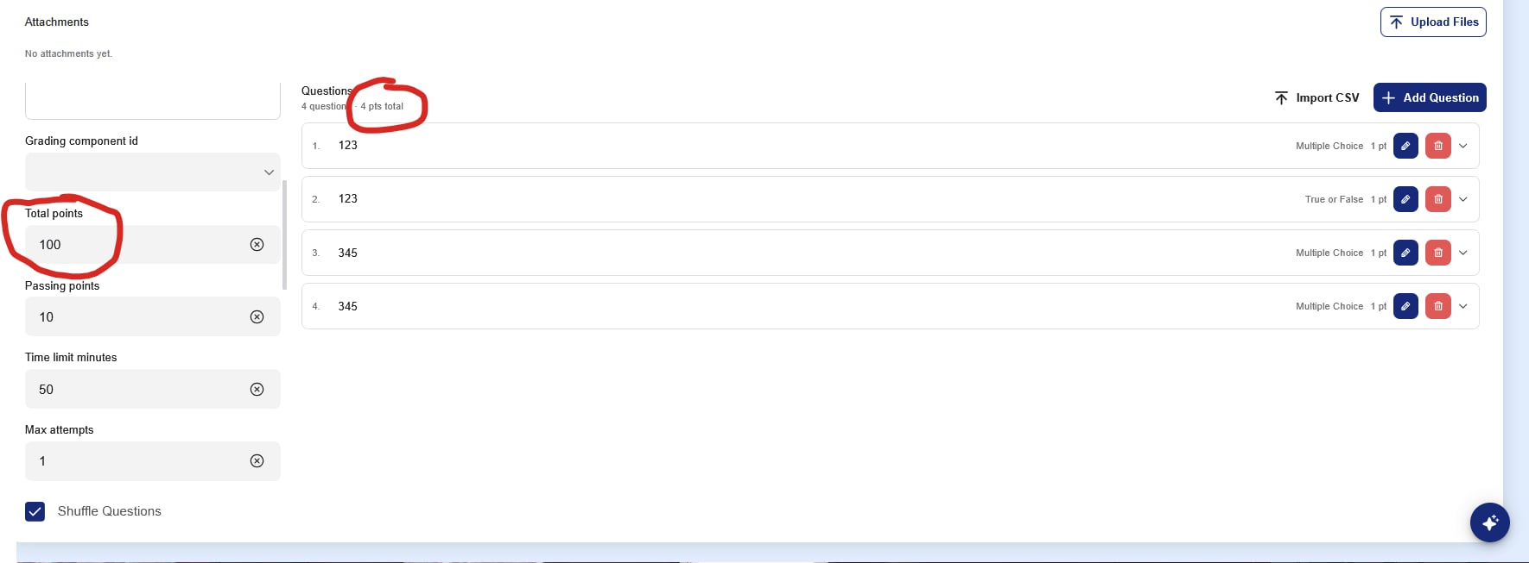
Uncertain yung interaction ng total points sa assessment builder dun sa amount of questions. Dapat auto calculation yung point value ng question based sa total points na naka dictate sa assessment builder unless changed otherwise. So kung 100 yung total points at 10 yung questions, magiging 10 ang point value per question, then pwede i-alter ng teacher yung points value ng question.

Yung grading component id rin pala.
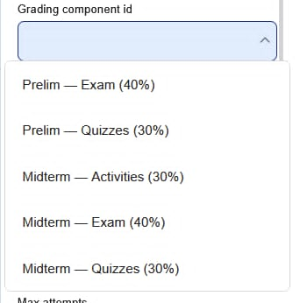
Link ng vid: https://drive.google.com/drive/folders/1sYRhwSiioofwhJ7AHvFELH4j5FLoR2gE?usp=sharing

